**Flutter App Development Course**

**DAY # 5**

**Task 1:**

**Source Code:**

**Main.dart**

import 'package:flutter/material.dart';

import 'quiz_brain.dart';

import 'package:rflutter_alert/rflutter_alert.dart';

QuizBrain quizBrain = QuizBrain();

void main() {

runApp(MyApp());

}

class MyApp extends StatelessWidget {

// This widget is the root of your application.

@override

Widget build(BuildContext context) {

return MaterialApp(

debugShowCheckedModeBanner: false,

home: QuizPage() ,

);

}

}

// ==============================================

class QuizPage extends StatefulWidget {

@override

_QuizPageState createState() => _QuizPageState();

}

class _QuizPageState extends State<QuizPage> {

List<Icon> scores = [];

void checkAns(bool userPickedAns){

bool correctAnswer = quizBrain.getCorrectAns();

setState(() {

//TODO: Step 4 - Use IF/ELSE to check if we've reached the end of the quiz. If so,

//On the next line, you can also use if (quizBrain.isFinished()) {}, it does the same thing.

if (quizBrain.isFinished() == true) {

//TODO Step 4 Part A - show an alert using rFlutter_alert,

//This is the code for the basic alert from the docs for rFlutter Alert:

//Alert(context: context, title: "RFLUTTER", desc: "Flutter is awesome.").show();

//Modified for our purposes:

Alert(

context: context,

title: 'Complete !',

desc: 'You have completed your quiz.',

).show();

//TODO Step 4 Part C - reset the questionNumber,

quizBrain.reset();

scores = [];

//TODO Step 4 Part D - empty out the scoreKeeper.

}

else{

if (userPickedAns == correctAnswer){

print("User picked it Right!!");

scores.add(Icon(Icons.check,color: Colors.green,size: 32,));

} else {

print("User Picked it Wrong !!");

scores.add(Icon(Icons.close,color: Colors.red,size: 32,));

}

quizBrain.nextQuestion(); }

});

}

// List <String> questions = [

// "Is Karachi the Biggest City of Pakistan ?" ,

// "Pakistan's Capital is Islamabad ?" ,

// "Pakistan Cricket Team has won 2 T20 Worldcups ?" ,

// "Is Munzesta Solution located in Pakistan ?" ,

// "Is Munzesta Solution giving their 100% to teach you ?" ,

// "Does Flutter support any other programming language other then dart ?" ,

// ];

// List <bool> answers = [true , true, false , true , true , false ];

// List <Question> questionBank = [

// Question (q: "Is Karachi the Biggest City of Pakistan ?" , a: true ),

// Question (q: "Pakistan's Capital is Islamabad ?" , a: true ),

// Question (q: "Pakistan Cricket Team has won 2 T20 Worldcups ?" , a: false ),

// Question (q: "Is Munzesta Solution located in Pakistan ?" , a: true ),

// Question (q: "Is Munzesta Solution giving their 100% to teach you ?" , a: true ),

// Question (q: "Does Flutter support any other programming language other then dart ?" , a: false ),

// ] ;

@override

Widget build(BuildContext context) {

return Scaffold(

backgroundColor: Colors.black,

body: Stack(

children: [

Stack(

children: [

Positioned(

child: Container(margin: EdgeInsets.only(top:440) ,height: 330, width: MediaQuery.of(context).size.width, alignment: Alignment.bottomCenter,

decoration: BoxDecoration(

gradient: LinearGradient(

begin: Alignment.topCenter , end: Alignment.bottomCenter ,

colors: [Colors.grey, Colors.grey[800]]),

borderRadius: BorderRadius.only( topRight: Radius.circular(120) , topLeft: Radius.circular(120) )

),

),

)

],

),

Column(

children: [

//Question

Center(child: Container( margin: EdgeInsets.only(top: 40, bottom: 20), height: 330, width: 400,

decoration: BoxDecoration(

// shape:,

// boxShadow: [BoxShadow(color: Colors.lime[10],blurRadius: 8,spreadRadius: 1),],

color: Colors.grey[800],

gradient: LinearGradient(

begin: Alignment.topCenter , end: Alignment.bottomCenter ,

colors: [Colors.grey[800], Colors.grey]),

borderRadius: BorderRadius.only( bottomLeft: Radius.circular(120) , bottomRight: Radius.circular(120) )

),

child:Center(child: Padding(

padding: const EdgeInsets.all(20.0),

child: Text(quizBrain.getQuestionText(), style: TextStyle(fontSize: 20),

),

)),

)),

// Scores

Padding(

padding: const EdgeInsets.only(bottom:15.0 , ),

child: Row( mainAxisAlignment: MainAxisAlignment.center,

children: scores,),

),

// True Btn

// Container(margin: EdgeInsets.only(top: 100),height: 60, width: 200,

// child: ElevatedButton(onPressed: (){

// checkAns(true);

// }, child: Text("True"))),

Padding(

padding: const EdgeInsets.only(top:100 , ),

child: Center(

child: Container(

// margin: EdgeInsets.only(top: 250, ),

width: 185, height: 55,

decoration: BoxDecoration(

boxShadow: [ BoxShadow(color: Colors.green[900], blurRadius: 8, spreadRadius: 1, offset: Offset(1, 3))],

borderRadius: BorderRadius.circular(30),

gradient: LinearGradient(colors: [Colors.green[900], Colors.green[600],Colors.green[900] ])

),

child: ElevatedButton(style: ElevatedButton.styleFrom(

shadowColor: Colors.transparent,

elevation: 0,

onPrimary: Colors.white,

primary: Colors.transparent,

shape: RoundedRectangleBorder(

borderRadius: BorderRadius.circular(20)

)),

onPressed: (){

checkAns(true);

}, child:

Text("True", style: TextStyle(letterSpacing: 2 , fontWeight: FontWeight.bold),)),

),

),

),

// False btn

// Container(margin: EdgeInsets.only(top: 40),height : 60, width: 200,

// child: ElevatedButton(

// style: ElevatedButton.styleFrom(

// ),

// onPressed: (){

// checkAns(false);

// }, child: Text("False")

// )),

Padding(

padding: const EdgeInsets.only(top:40 , ),

child: Center(

child: Container(

// margin: EdgeInsets.only(top: 250, ),

width: 185, height: 55,

decoration: BoxDecoration(

boxShadow: [ BoxShadow(color: Colors.red[900], blurRadius: 8, spreadRadius: 1, offset: Offset(1, 3))],

borderRadius: BorderRadius.circular(30),

gradient: LinearGradient(colors: [Colors.red[900], Colors.red[600],Colors.red[900] ])

),

child: ElevatedButton(style: ElevatedButton.styleFrom(

shadowColor: Colors.transparent,

elevation: 0,

onPrimary: Colors.white,

primary: Colors.transparent,

shape: RoundedRectangleBorder(

borderRadius: BorderRadius.circular(20)

)),

onPressed: (){

checkAns(false);

}, child:

Text("False", style: TextStyle(letterSpacing: 2 , fontWeight: FontWeight.bold),)),

),

),

),

// TODO: add any widget here , testing todo comment

],

),

],

) ,);

}

}

**Quiz_brain.dart**

import 'question.dart';

class QuizBrain {

int _questionNo = 0;

List<Question> _questionBank = [

Question(qtn: 'Pakistan was founded in 1947', ans: true),

Question(qtn: 'Flutter is maintained by Facebook', ans: false),

Question(qtn: "Is Munzesta Solution located in Pakistan ?", ans: true),

Question(qtn: 'Firebase is one of the backend databases for Flutter',ans: true),

Question(qtn: 'Is E=mc^3 ?', ans: false),

Question(qtn: "Pakistan Cricket Team has won 2 T20 Worldcups ?", ans: false),

Question(qtn: 'More CPU cores means slower PC', ans: false),

Question(qtn: 'Ram makes PC faster', ans: true),

Question(qtn: 'Laptop has no heating issues', ans: false),

] ;

void nextQuestion(){

if(_questionNo < _questionBank.length - 1){

_questionNo++;

}

print(_questionNo);

print(_questionBank.length);

}

String getQuestionText(){

return _questionBank[_questionNo].questionText;

}

bool getCorrectAns() {

return _questionBank[_questionNo].questionAnswer;

}

bool isFinished() {

if (_questionNo >= _questionBank.length - 1) {

//TODO: Step 3 Part B - Use a print statement to check that isFinished is returning true when you are indeed at the end of the quiz and when a restart should happen.

print('Now returning true');

return true;

} else {

return false;

}

}

//TODO: Step 4 part B - Create a reset() method here that sets the questionNumber back to 0.

void reset() {

_questionNo = 0;

}

}

**Question.dart**

class Question {

String questionText= ' ';

bool questionAnswer = true;

Question({String qtn=' ', bool ans=false}) {

questionText = qtn;

questionAnswer = ans;

}

}

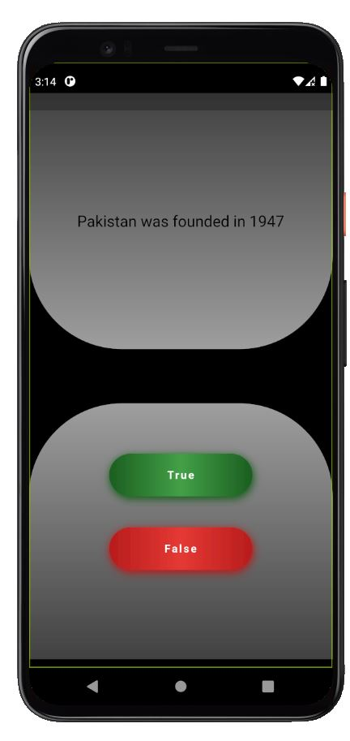**Output:**

